July 2022 County Councillor Report – Cllr Robin Bennett
Robin.bennett@Oxfordshire.gov.uk

Help with cost of living webpage
We’ve assembled a webpage on help available as living costs and inflation continue to rise-
A wide range of support is available from both county and district councils, as well as other local organisations.
https://www.oxfordshire.gov.uk/council/help-rising-living-costs
Campaign: Annual savings of up to £2,318.23 for commuters who switch car for busA new campaign is designed to highlight the financial advantage of taking a bus over a private vehicle. With the cost of fuel at record levels, commuters and leisure travellers can achieve significant savings by swapping using private vehicles for buses, where practical. Oxfordshire County Council is delivering the campaign in partnership with Oxford Bus Company, Thames Travel and Stagecoach. Petrol and diesel prices reached record highs this month, with the cost of filling up a 55-litre tank family car now more than £100 on average. Fresh data collated by bus operators has revealed savings which can made, even before factoring in paying to park:
- A return journey between Witney and Oxford via Stagecoach S1 five days a week achieves an annual saving of up to £2,230.30 compared to using a private vehicle.
- A return journey between Abingdon and John Radcliffe Hospital via Oxford Bus Company’s X3 service saves up to £2,318.23 per year compared to using a private vehicle.
Bus passenger levels are currently running at between 75 and 80 per cent of pre-COVID levels; Oxfordshire County Council’s cabinet recently approved its draft enhanced partnership (EP) document – a plan to help bring passenger levels back to pre-pandemic levels - for submission to the government. After public consultation, the final version will be submitted to the government later this year aiming to secure Bus Service Improvement Plan funding of £12.7m.
HIF1 Didcot and Culham infrastructure project
Although I and others raised serious concerns at the meeting, Oxfordshire County Council’s cabinet has decided to continue to the next stage of the HIF1 Didcot and surrounding areas major infrastructure project with a revised funding deal with Government.
Up to £30m funded from council borrowing will be combined with further funds from Homes England and the Oxfordshire LEP to aim to deliver the project by mid-2026. Homes England have also agreed that the Council can make improvements to the sustainability of the scheme during the next phase of design. Cabinet agreed to provide a maximum of £30m in additional funding, and to write to Homes England to make clear there could be no further contribution from Oxfordshire County Council.
The county council has secured assurances from Homes England that it would work in partnership to identify additional funding sources or re-scope the project during the funding period, should that be required in exceptional circumstances. ​
.
OXFORDSHIRE County Council adopts ‘Vision Zero’
Recent tragic incidents on our roads have focused everyone’s minds on the vital importance of making our roads safer for all users, especially the most vulnerable.
The adoption of Vision Zero for Oxfordshire signals a clear ambition and commits the council to taking a new approach.

The council wants to eliminate all deaths and serious injuries in road crashes in the county. It has launched Vision Zero, an initiative designed to reach the target by 2050 with interim targets of a 25 per cent cut in casualties by 2026 and a 50 per cent reduction by 2030. The average number of deaths on Oxfordshire roads each year over the past 10 years is 25 and the total of serious injuries is 210. For more info on Vision Zero- https://visionzeronetwork.org/about/what-is-vision-zero/
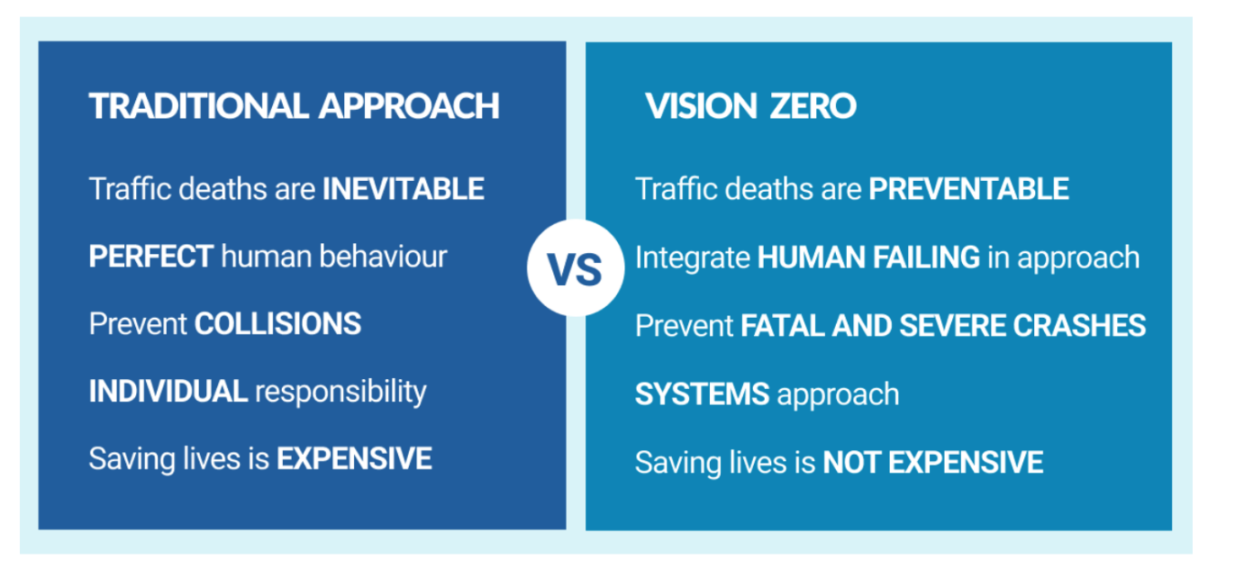

Update on Homes for Ukraine – rematching (where initial arrangements aren’t working)
The county council are planning to create a new team to lead on the rematching of households where sponsorship arrangements cannot continue. Funding for the team will come from the government’s existing commitment to provide local authorities with £10,500 per guest. The rematching team will sit outside of any existing homelessness teams and will have access to an emergency accommodation fund (£30,000), which will help families avoid becoming homeless.
As per government guidance, rematching will only be used where it is unviable or unsafe for the sponsorship relationship to continue (or when a DBS/accommodation check has failed). It will only apply for guests who received a visa through the Homes for Ukraine scheme. OCC will be working to keep rematches to a minimum, to maintain capacity for re-housing those most in housing need. If a guest family already has children enrolled in schools, the council will prioritise rematching as close to the education setting as possible.
For general Ukraine queries, go to:
- Website: www.oxfordshire.gov.uk/ukraine
- Oxfordshire Ukraine helpline: +44 1865 966444 / 01865 966 444 (opening hours for Monday 30 May - Wednesday 1 June, 8.45am - 5pm, bank holiday Thursday 2 June - Saturday 4 June, helpline closed but email is being monitored 10am - 3pm, closed Sunday 5 June).
- Email: ukraineresponse@oxfordshire.gov.uk

